OFFICIAL LEAGUE ROSTER - SOCCER
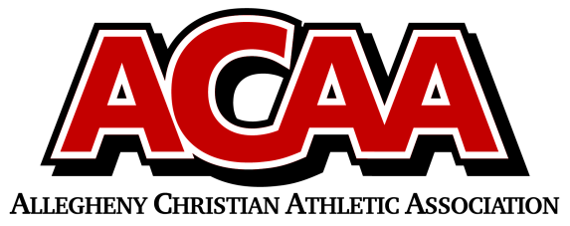

School Name: Johnstown Christian
Team Colors: Royal Blue and White
Overall Wins ___ Losses ____ Ties ___
ACAA Wins ___ Losses ____ Ties ___ OPPONENT: __________________________
DATE: _________
Number | Name | Year | Position | Homeschool
20 | Daniel Harper | 12 | D | no
15 | Matthew Blough | 12 | G/M | no
17 | Brayden Kibbe | 12 | M | no
9 | Dorin Cook | 12 | D | no
16 | Jeremiah Taylor | 12 | F/M | no
18 | Deklan Putman | 12 | D | no
23 | Issak Stanley | 11 | D | no
11 | Adam Habecker | 11 | M/D | no
10 | Levi DiGuardi | 11 | M/F | no
19 | Keyahno Richardson-Toney | 11 | M/F | no
8 | Carter Rudnik | 10 | M | no
12 | Malachi Dean | 10 | M | no
5 | Cameron Ledwich | 9 | M/F | no
14 | Sam Williams | 8 | D | no
21 | Jaxson Empfield | 8 | G/D | no
7 | Gavin Custer | 7 | M/D | no
22 | Alex Hensel | 7 | D | no
1 | Colton Rudnik | 7 | F/M | no
13 | Daniel Cooper | 7 | M/D | no
2 | Abram Shaffer | 7 | F/M/D | no
3 | Sean Fassnacht | 7 | F/M | no
6 | Cooper Ashbrook | 7 | M/D | no
4 | Luca Desrochers | 7 | F/M/D | no

Head Coach: Brian Grove
Asst. coach: Jeff Grove
Asst. coach: Dave Sprankle

Official ACAA League Team Roster. to be submitted to the scorer’s table before each game.

